Lab Class: Based on OOP, use Models, Migrations and Eloquent
Table of Contents
Based on the Lecture Slides and Support Material
Intro
Rearchitecting duplicate information
Classes
Creating a method
Introducing Models
How to include a Model - use
Making more use of the Model
Dealing with attempts to access non-existent Jobs
db:show
Viewing the Database
migration:fresh
Object Relational Mapper
Mass Assignment
$fillable
Mini Challenges

Based on the Lecture Slides and Support Material
You may watch the following videos for step-by-step demo
https://laracasts.com/series/30-days-to-learn-laravel-11/episodes/7
In this episode of the "30 Days to Learn Laravel" series, the focus is on important approaches such as autoloading, namespaces, and the MVC architecture. Also looks at what happens if a malicious user attempts to view non-existent Jobs.
https://laracasts.com/series/30-days-to-learn-laravel-11/episodes/8
In episode 8 of the "30 Days to Learn Laravel" will move from a static set of Jobs to using a Database to store the Jobs using migrations as PHP blueprints that determine your table structure.
https://www.youtube.com/watch?v=gHQ-OT8V5VU&t=855s
The ninth episode of the "30 Days to Learn Laravel" shows how to use the eloquent ORM to interact with the dB as an object.

Intro
Following the instructions from last week, clone down your repo into the Herd folder. Using the mini-challenge steps from the Week 3 practical, you should be able to use the composer install commands to install the vendor files.

The following link has useful steps if you run into difficulty.
How to clone and setup Laravel project from GitHub - DEV Community
If you have already modified your .gitignore file to retain the .env file then you can skip step 7 in the above link and the step 8 block of code would look like this.
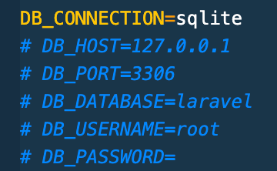

Make sure you commit your work regularly throughout this practical to your Azure repo.

Rearchitecting duplicate information
Let’s deal with the duplicated array of job listings.
Select and cut the following part in your web.php file
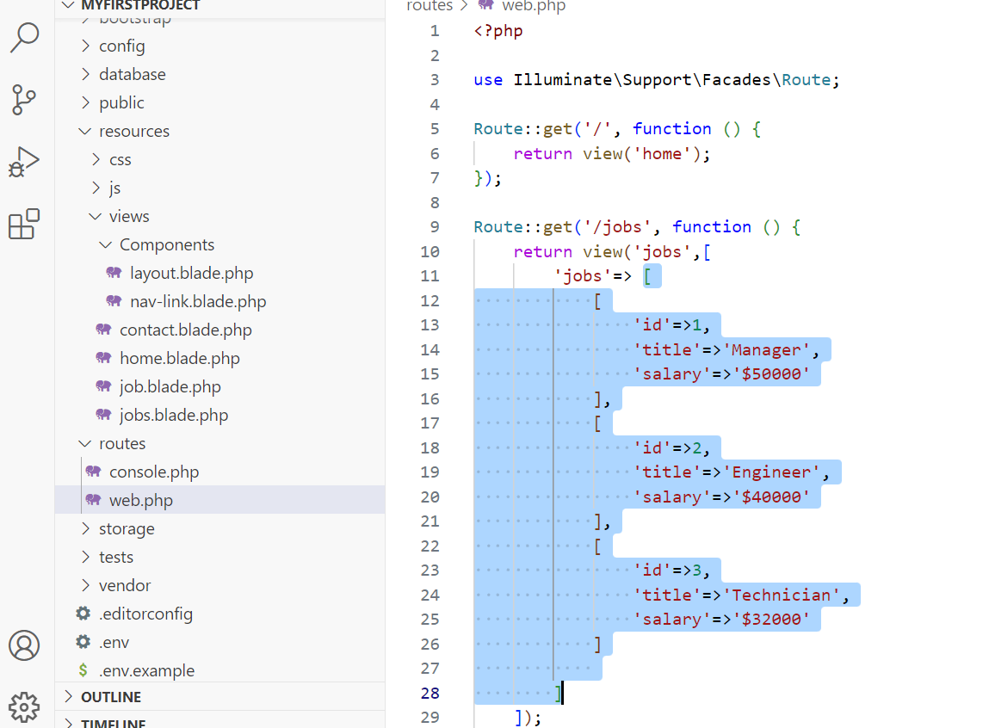
Create the jobs variable on the top and paste the code there as shown below
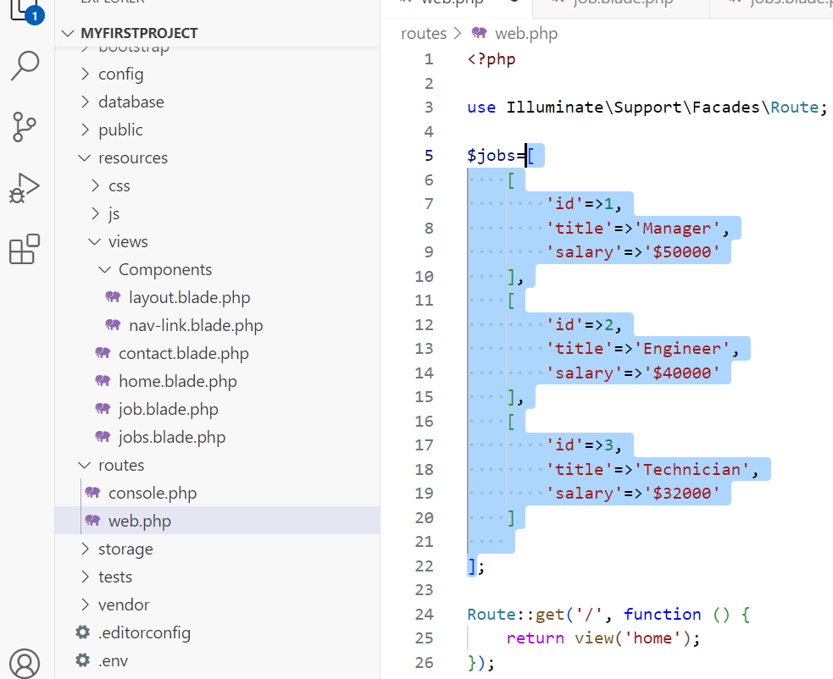
Now let’s us this variable as follows
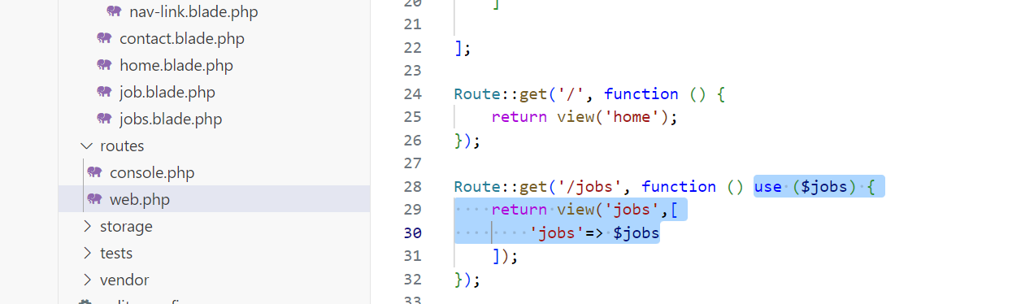

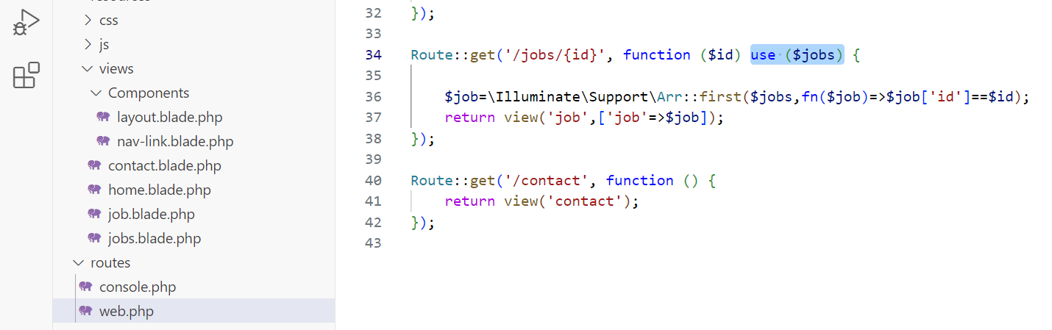

Classes
Let’s make it further systematic by selecting the jobs variable data, cutting it and create a new class with the name Job and a method inside that will return all the jobs
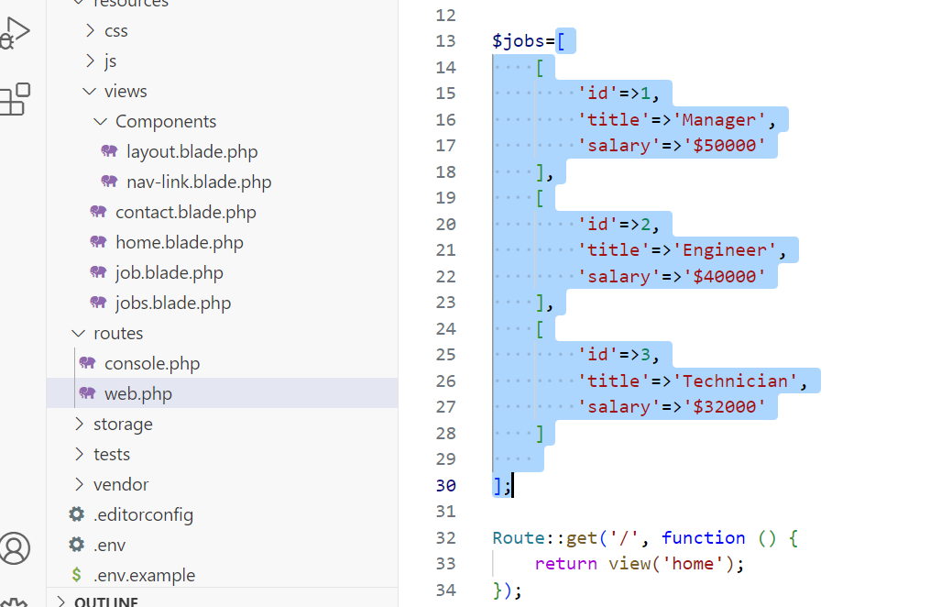

Creating a method
We will create a class and a method inside it as follows
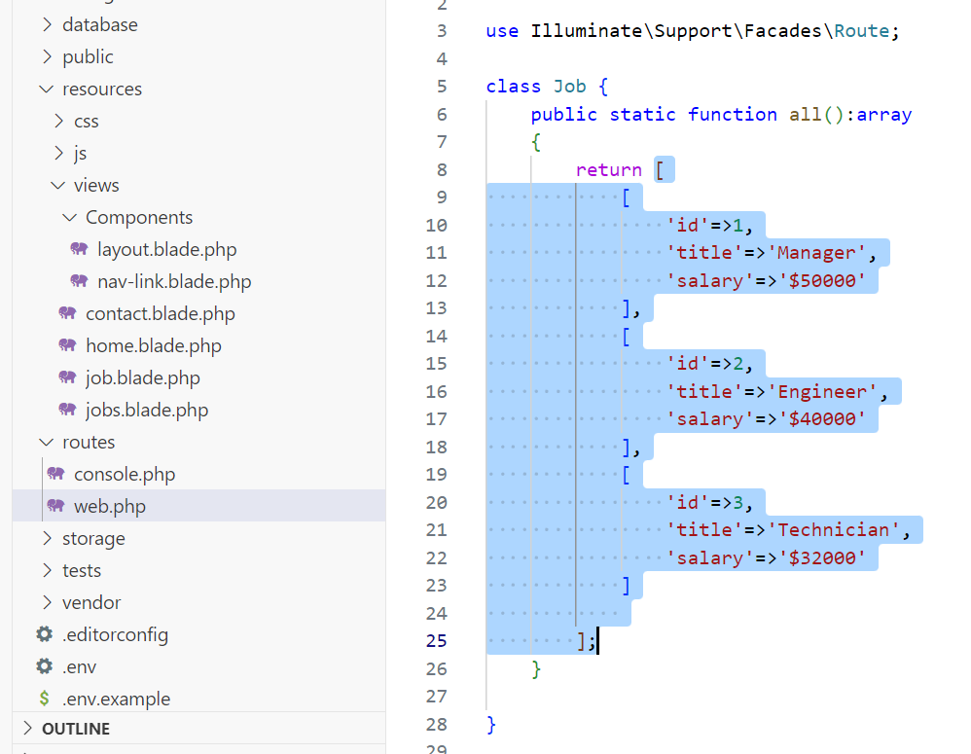

Now let’s use this method. Make sure you delete use ($jobs)
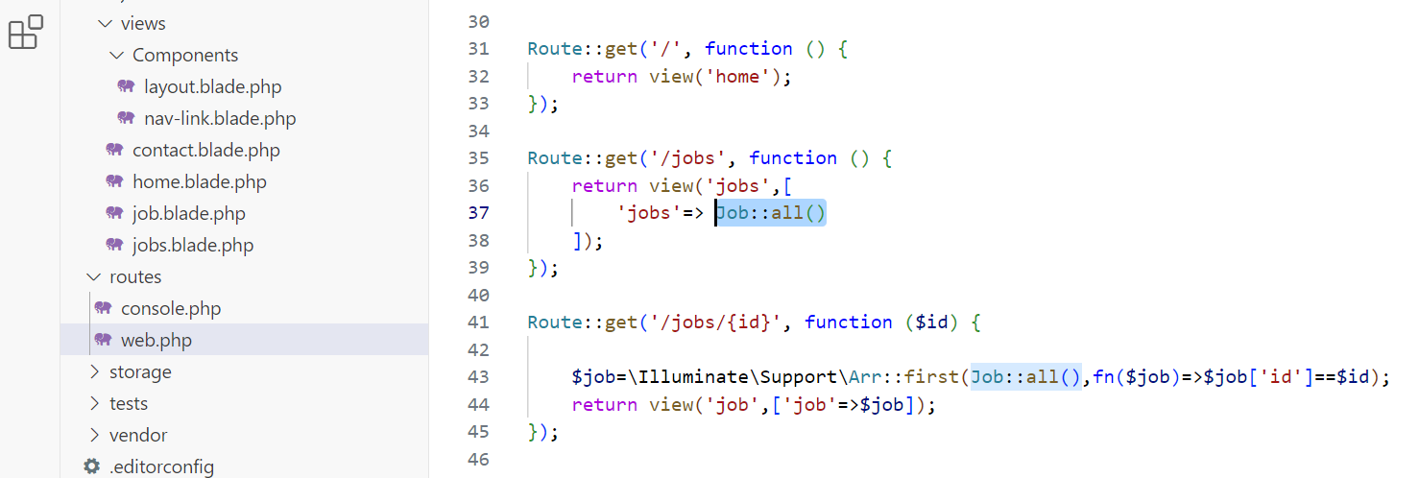
At this stage, you should commit your changes and push them to your remote repository.

Introducing Models
Create a new file with the name Job.php in the Models directory as follows
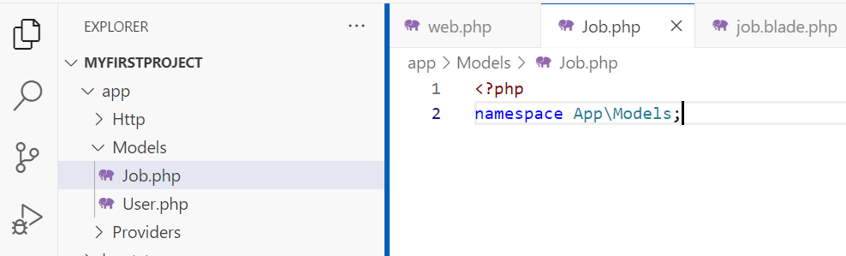
Now cut the Job class code from web.php and paste it in the new Job.php file
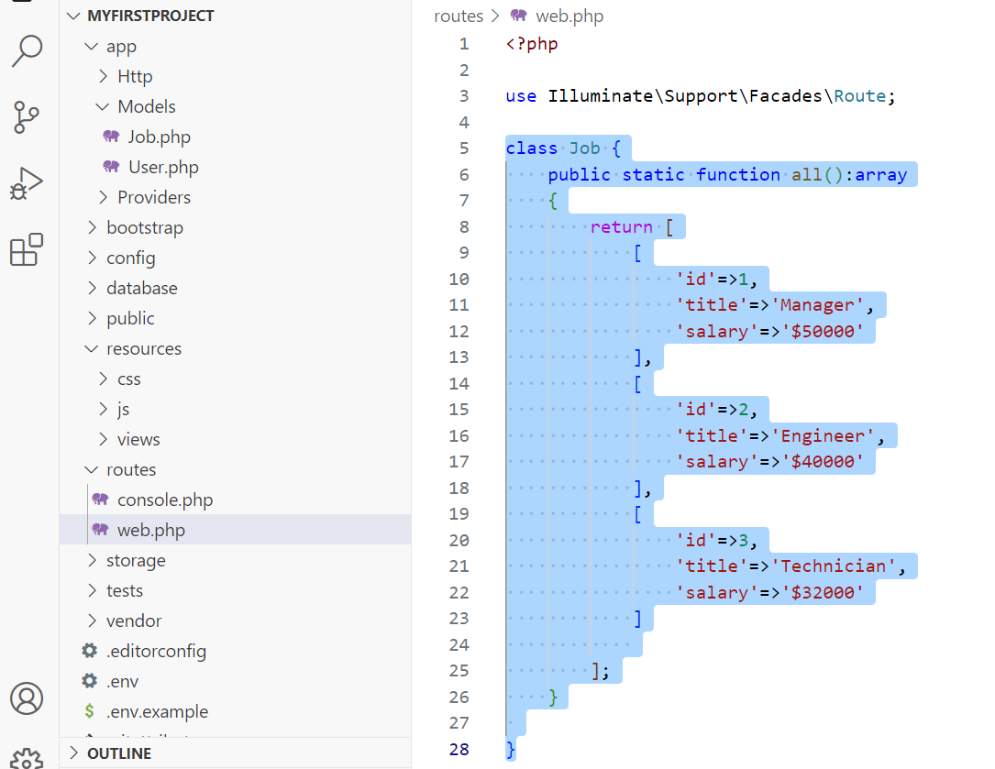

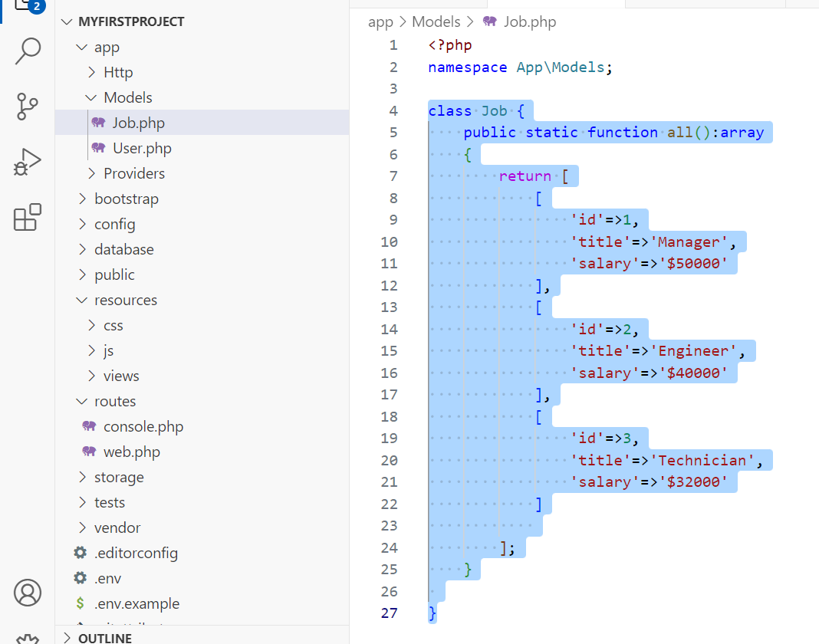

How to include a Model - use
Now to use this new Job class in the Models, we have to add this one line in the web.php
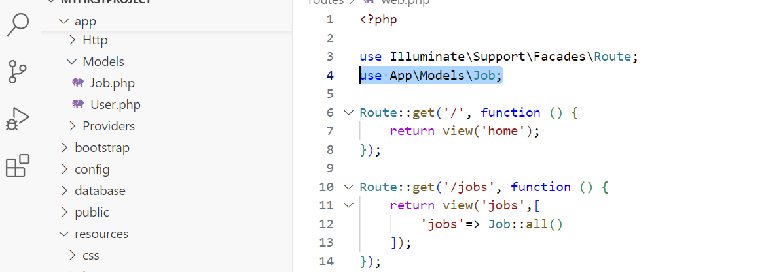
Save all and test your application.

Making more use of the Model
We can move the selected code to the Job class to make the things more systematic
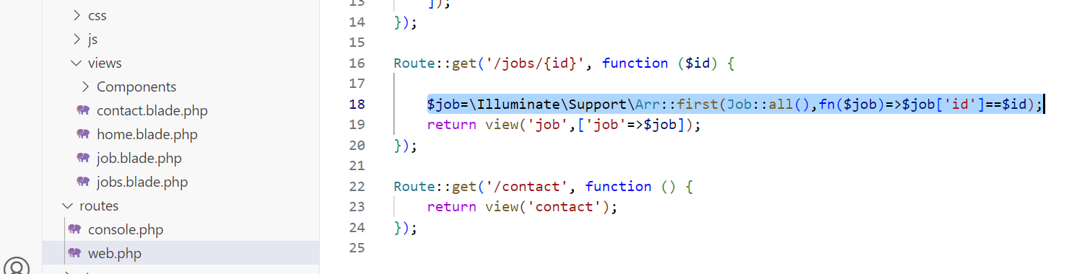

Move it to the Job.php with little modifications as shown below:
public static function find(int $id):array
{
return \Illuminate\Support\Arr::first(static::all(), fn($job)=>$job['id']==$id);
}

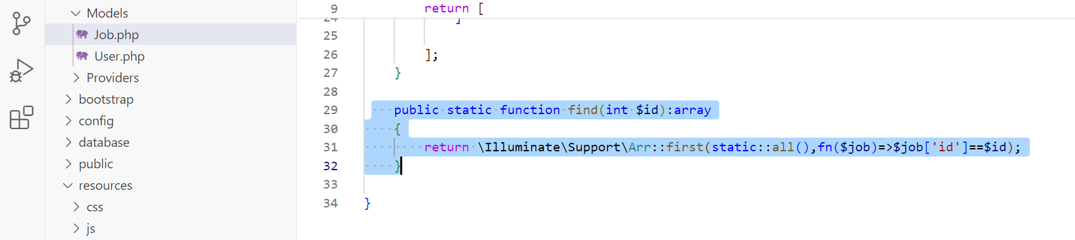

Now change the code in web.php to call this method as follows
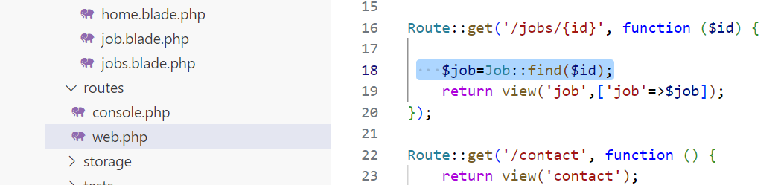

Dealing with attempts to access non-existent Jobs
0Let’s add exception handling in case the job is not found. For example, if I put http://myfirstproject.test/jobs/4 in the browser.
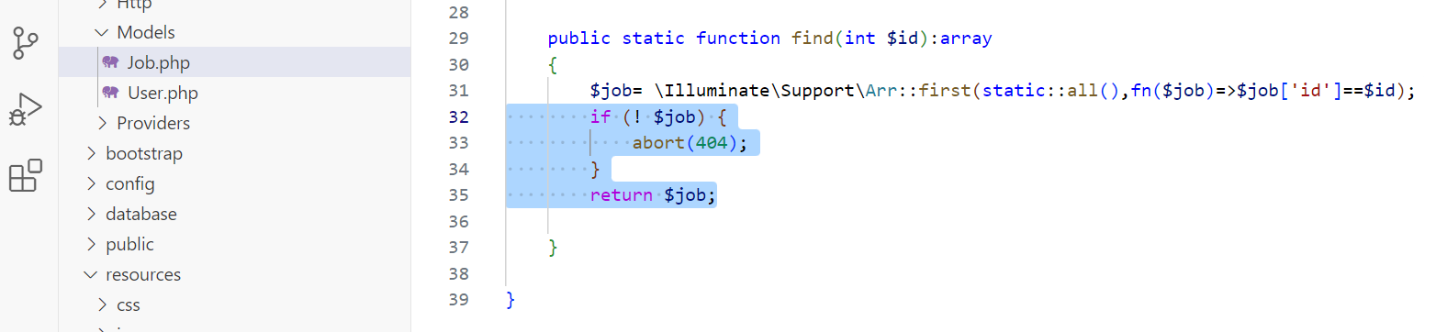

db:show
Run php artisan db:show command on the command line inside your project directory and it will show details of the database.
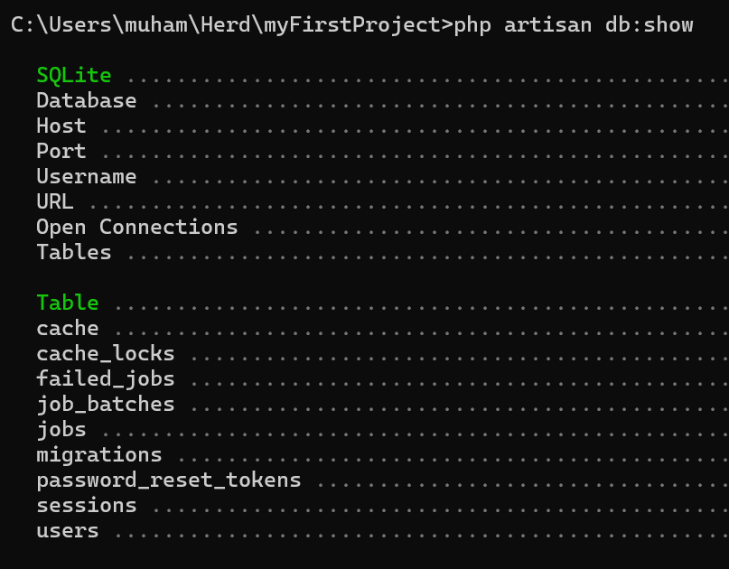

Let’s delete this database as follows:
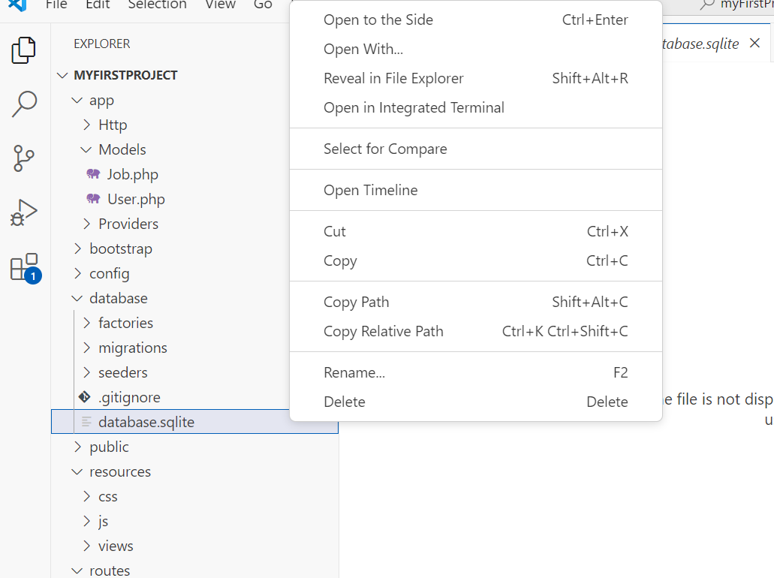

Let’s run ‘php artisan migrate’ command to create the database again manually.
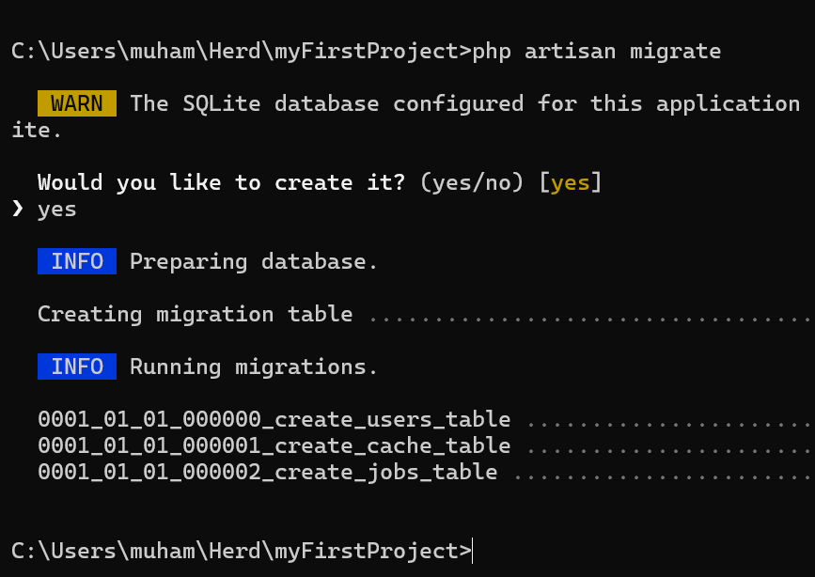

Viewing the Database
We can download and install the ‘TablePlus’ tool for browsing our database.
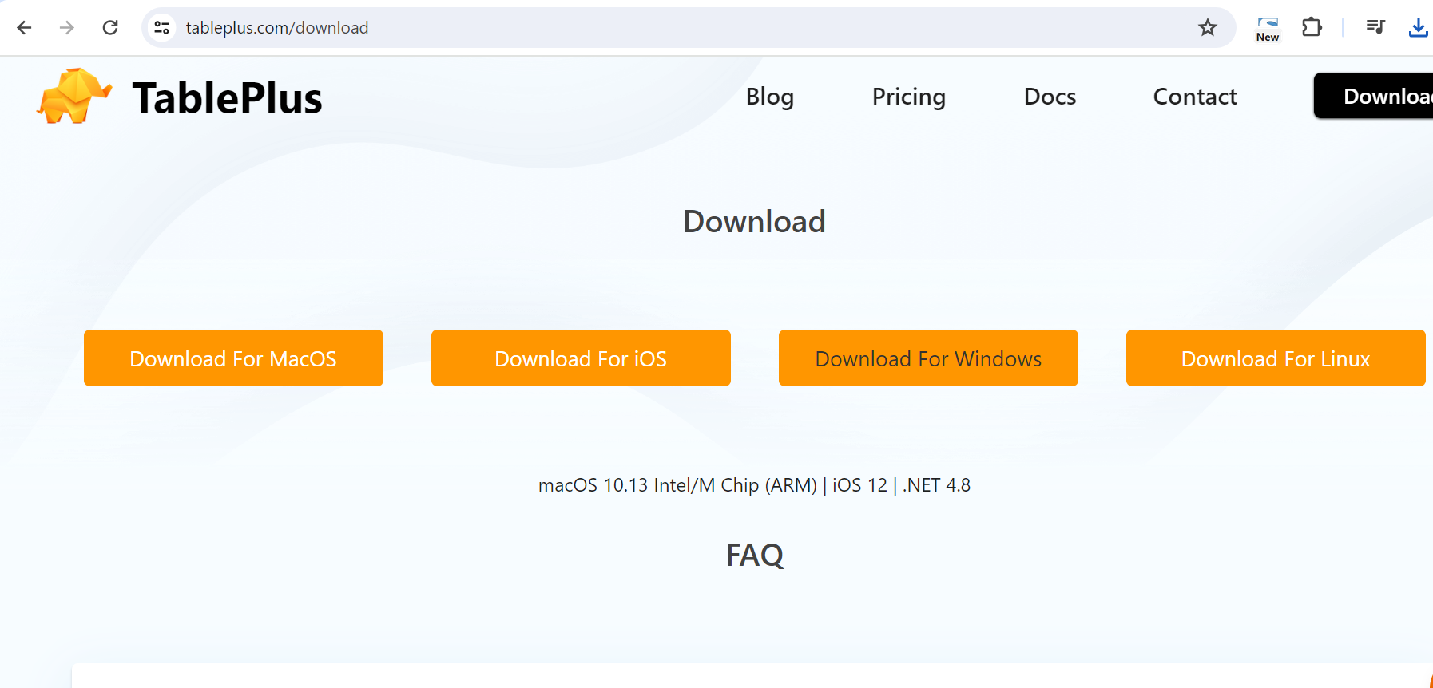
Open the tool, click on + and select SQLite.
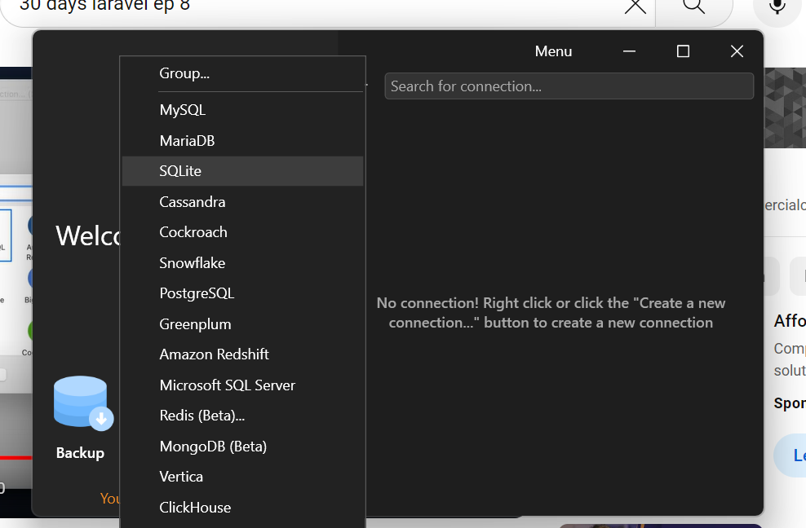
Give it some name and select the database file of your project. Save it.
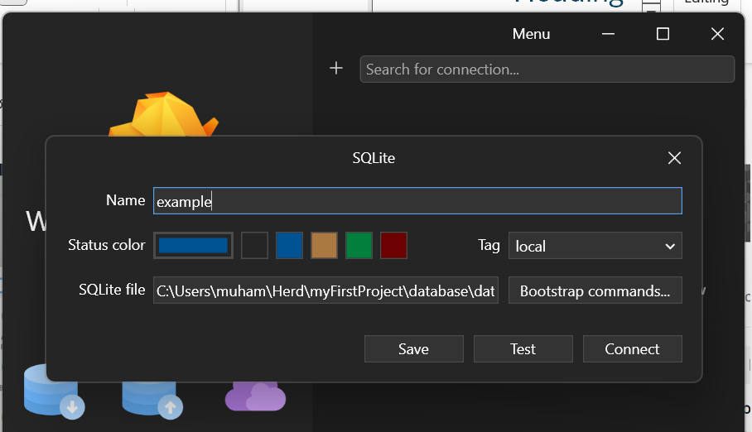

Double click the database name to browse it.
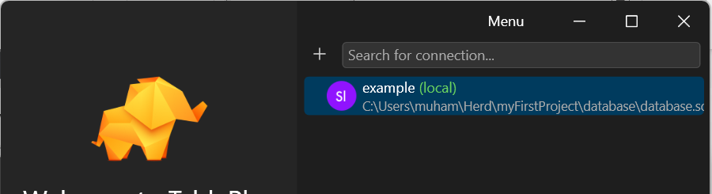
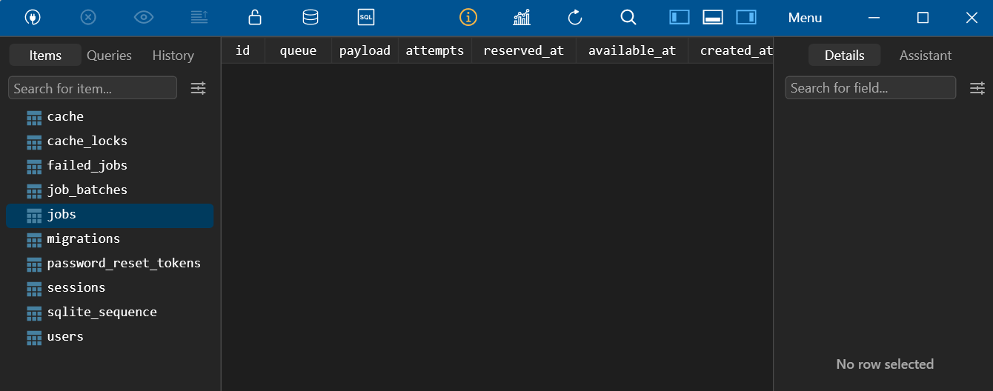

Click on ‘Structure’ to view the structure of any table.
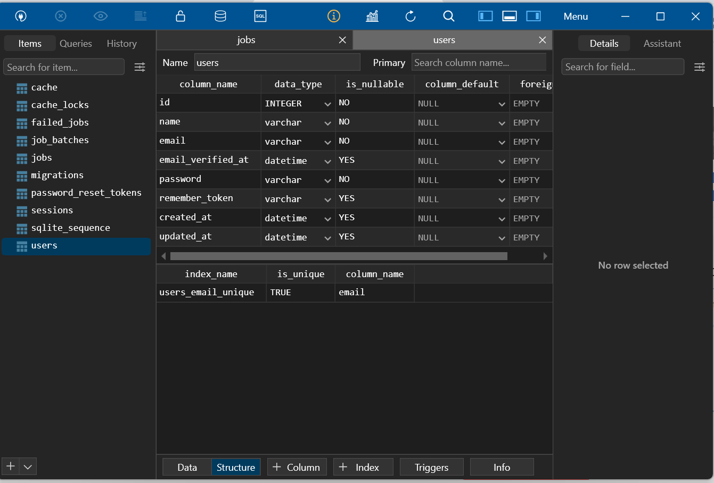

Let’s open the migration file to change the ‘name’ field in the Users table to ‘first_name’ and ‘last_name’
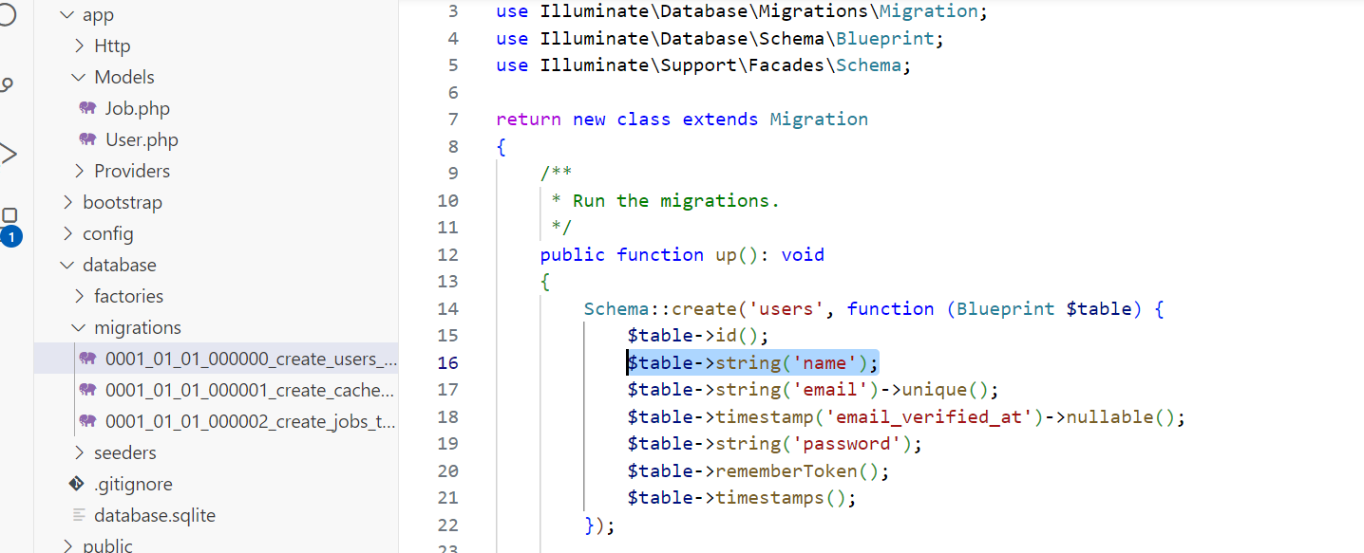

The above line will be replaced with the following two lines
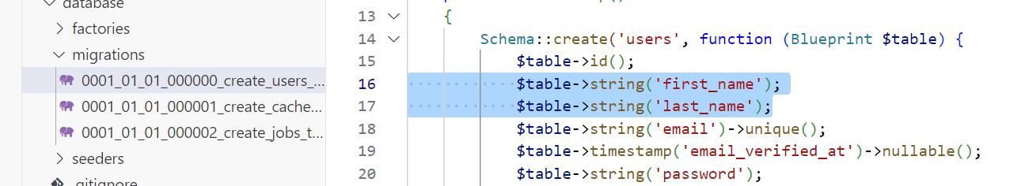

migration:fresh
Run ‘php artisan migrate:fresh’ command so that the database is updated according to the changes made in the migration file
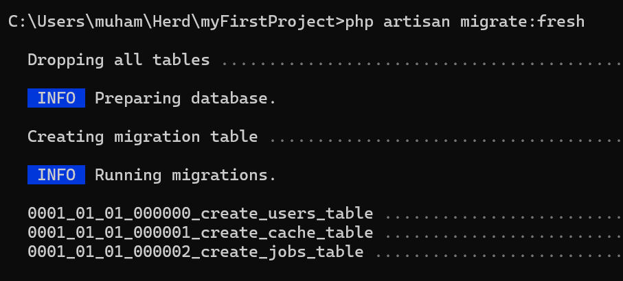

Close your TablePlus and restart it to see the changes in the table. (This is a known issue of sqlite and TablePlus that it does not automatically see the change.)
Now let’s create our own job listing table.
Type the following command
php artisan make:migration
It will ask for the name, give it the following name
create_job_listings_table
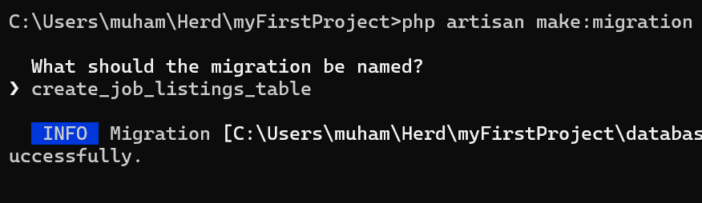
Go the newly created migration file and add the following two lines as per our requirements of the job listings table
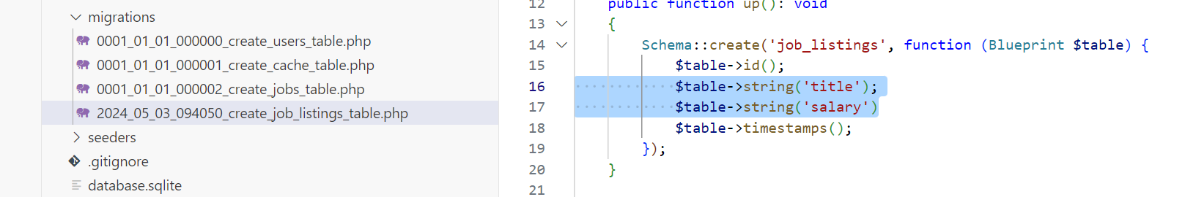
Save the file, go to the command line and run ‘php artisan migrate’
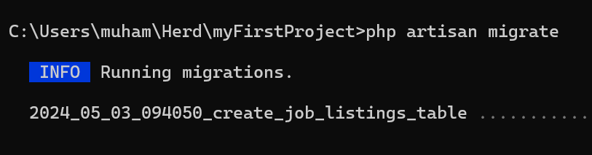
Close and re-open the TablePlus tool and you should be able to see the newly created job listing table.

Object Relational Mapper
Let’s see ORM (Object Relational Mapper) which maps an object in a database to an object in php.
Open Job.php and delete the following selected code
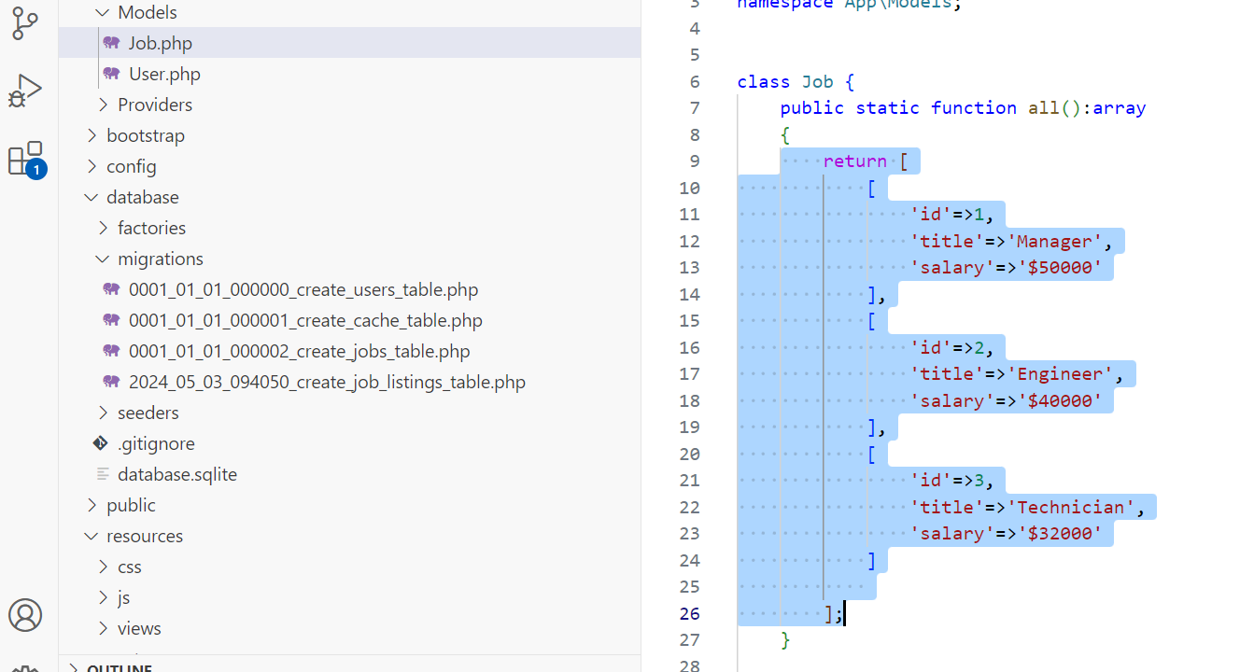
Now add ‘extends Model’ to the Job class
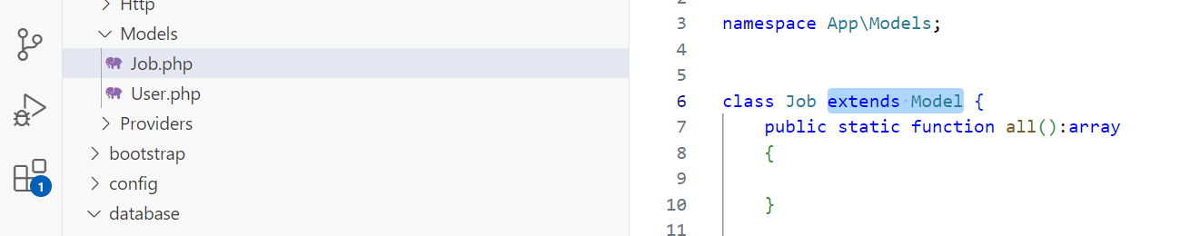
Add ‘use \Illuminate\Database\Eloquent\Model;’ as follows
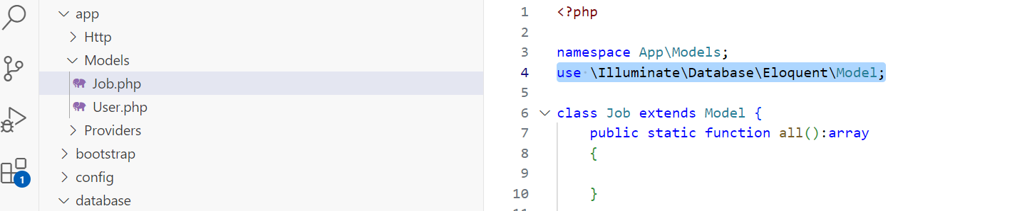
Delete the following part
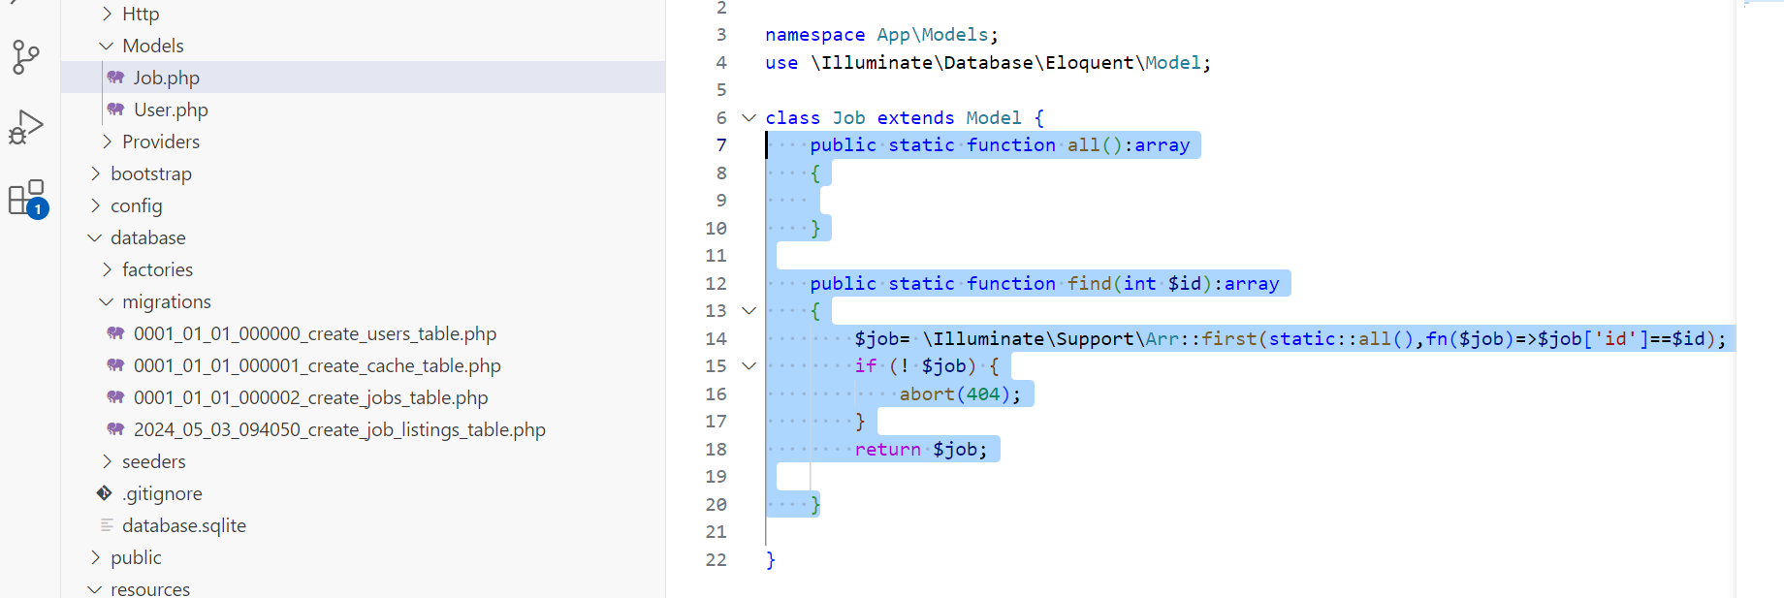

Add the following line
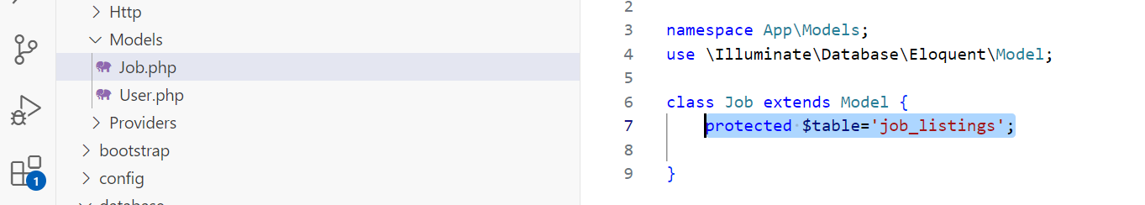

Go to TablePlus and add few rows of data using ‘+ Row’ option at the bottom.
For the dates you may want to add the current date using the following example format for both the created_at and also the updated_at:
YYYY-MM-DD HH:MM:SS, for example: 2025-02-27 11:53:00
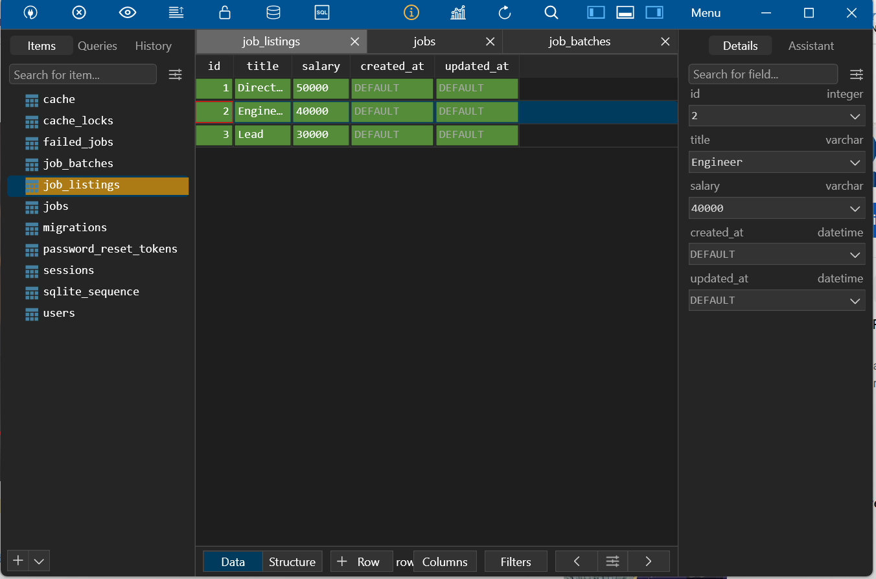
Press CTR+S to commit the changes.
Test your app to see the eloquent in action.

Let’s see further the eloquent in action
Go to the command line (make sure you are inside your app directory) and type php artisan tinker
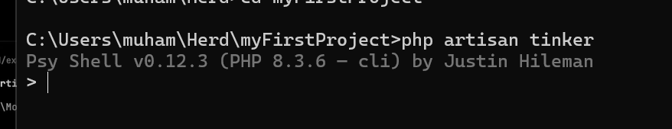

Mass Assignment

$fillable
Type the following command to add a row to your table
App\Models\Job::create(['title'=>'Technician', 'salary'=>'30000']);
This will throw an error
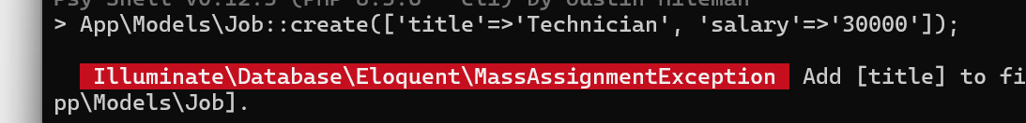
To solve this issue, go to your Job class and add the following line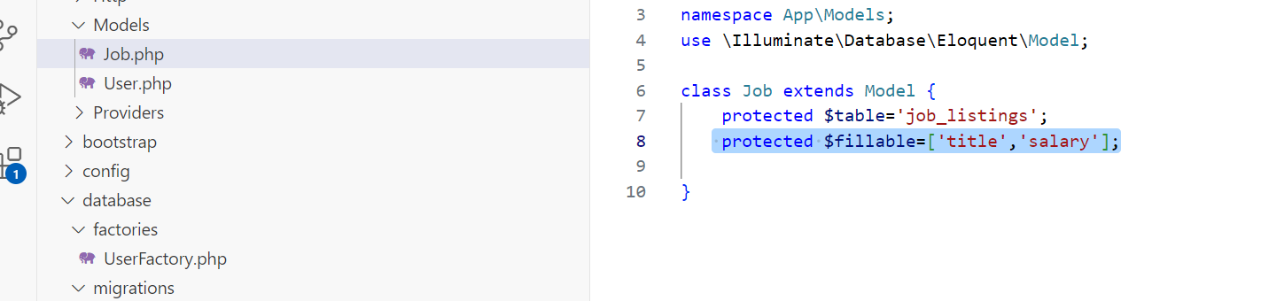
Now on command line, press CTRL+C and retype the commands that we already did
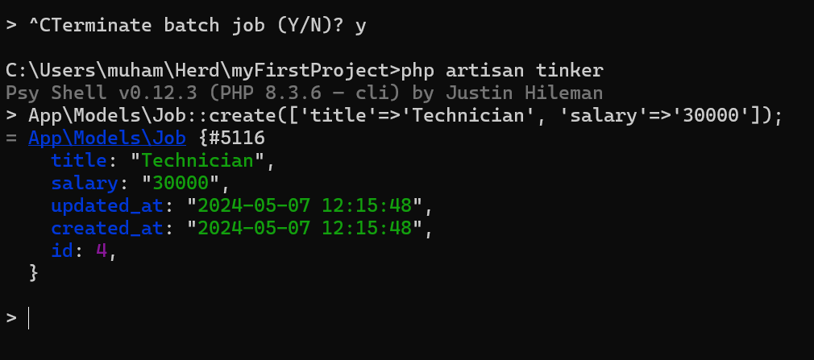
Type ‘App\Models\Job::all();’ to see all the listings.
Similarly, the find method will search for an item for you.
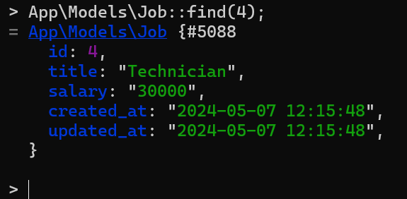
Press CTRL+C to go to the command line.
Type and run ‘php artisan help make:model’ to help of the make a model command. You can use this command to make a new model and associated migration as well.
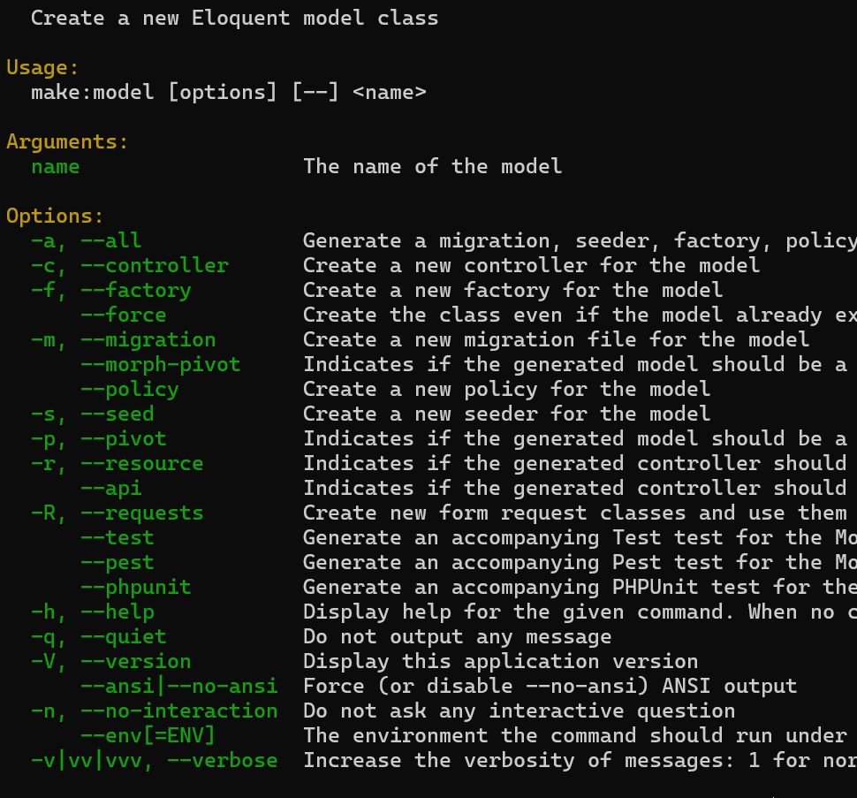

Ensure that you commit your changes and push them to your remote repository.

Mini Challenges
Make use of Tinker to add and view records from the dB
Use TablePlus to add and view records from the dB

